
LWR+ Task-Based Activities are aligned with the competencies and task groups within the Ontario Adult Literacy Curriculum Framework (OALCF) including level indicators and performance descriptors. They can also be used as stand-alone activities for learners at (IALS) Level 1 and 2 who are not using Laubach Way to Reading skill books.

Laubach Literacy Ontario
LWR Plus
Task-Based Activities

for the LWR Series

Laubach Way to Reading (LWR) Book 3
Laubach Literacy Ontario Task-Based Activities for LWR Book #3
INTRODUCTION
LWR+ Task-Based Activities
Each of the task-based activities linked to the Laubach Way to Reading four-book series were developed using the criteria outlined by the Ontario Adult Literacy Curriculum Framework (OALCF).
The goal of this project was to create Canadian curriculum for International Adult Literacy Survey (IALS) Level 1 and 2 learners. Because the OALCF is linked to Canada’s Essential Skills and loosely tied to IALS levels, these resources will have applicability across Canada.
The task-based activities, while connected to each lesson in the Laubach Way to Reading series, can also be used as a stand-alone activity without the need for using the series. Each activity is also posted on our website, as a free download.
If you wish to purchase printed and boundLWR+ booklets, you can place your order in our online bookstore at http://www.laubach-on.ca/bookstore/llo-publications.
Please refer to the Task Based Activities Chart showing OALCF Competencies and Task Groups covered, as well as the Practitioner Guide on the following pages, for more detail.
Literacy practitioners have permission from the publisher to make copies of LWR+ for classroom and tutoring use.
Laubach Way to Reading (LWR) Series
Laubach Way to Reading is a basic reading and writing series developed primarily for adults with little or no reading ability. The series consists of four levels with student skill books, workbooks and correlated readers for learner use. The teacher’s edition for each level gives detailed instructions and lesson plans. Each lesson plan contains reading, writing, spelling and comprehension, as well as a “Meeting Individual Needs” section. The series is published by New Readers Press, a division of Pro-Literacy International. Laubach Literacy Ontario is a Canadian Distributor of New Readers Press material. For more information about the Laubach Literacy Bookstore, or to place orders, please visit http://www.laubach-on.ca/bookstore.
Member Support
This project was developed in response to member agency requests for Canadian resources that support Level 1 and 2 learners, and that can be easily understood and used by volunteer tutors.
Member Quotes
“These new task-based activities will be used by the staff and tutors to teach the students skills that will lead towards their actual goals.”
“Having Canadian material to use with our learners, that would provide our practitioners with a bank of materials referenced to the OALCF, would be extremely useful not only to our program, but to all of the literacy agencies in Ontario.”
 | TASK-BASED ACTIVITIES CHART FOR LWR BOOK #3
 |  |  | OALCF Competencies and Task Groups
 |  |  | Competencies | Find and Use Information |  |  | Communicate Ideas and Information |  |  |  | Understand and Use Numbers |  |  |  | Use Digital Technology | Page #
Lesson # |  |  | Activity  Description | Read continuous text | Interpret documents | Extract info from films, broadcasts, etc. | Interact with others | Write continuous text | Complete and Create Documents | Express oneself creatively | Manage money | Manage time | Use measures | Manage Data | Use Digital Technology | Page #
 |  |  | Task Group # | A1 | A2 | A3 | B1 | B2 | B3 | B4 | C1 | C2 | C3 | C4 | D
1 |  |  | Calculate cost of meal using online menu |  |  |  |  |  | .1b |  | .1 |  |  |  | 2 | 4
2 |  |  | Complete a babysitter information sheet | .1 |  |  |  |  | .1a |  |  |  |  |  |  | 10
3 |  |  | Create a budget for a 3-day vacation |  |  |  |  |  | .1a |  | .1 |  |  |  |  | 16
4 |  |  | Use a table to determine correct paint sheen |  | .2 |  |  |  |  |  |  |  |  |  |  | 22
5 |  |  | Review a wedding checklist |  | .2 |  |  |  |  |  |  | .1 |  |  |  | 29
6 |  |  | Wedding cake recipe |  | .2 |  |  |  |  |  |  |  | .2 |  |  | 36
7 |  |  | Make a list of items for a first aid kid |  |  |  |  |  | .1a |  |  |  |  |  |  | 42
8 |  |  | Use a grocery flyer to plan purchases for a party |  | .1 |  |  |  |  |  | .1 |  |  |  |  | 47
9 |  |  | Fill in a warranty card |  |  |  |  |  | .1a |  |  |  |  |  |  | 53
10 |  |  | Interpret a hockey schedule |  | .2 |  |  |  |  |  |  | .1 |  |  |  | 58
11 |  |  | Research getting a driver’s licence | .2 | .2 |  |  |  |  |  |  |  |  |  | 2 | 64
12 |  |  | Create a physical activity plan | .2 |  |  |  |  | .2a |  |  | .1 |  |  |  | 71
13 |  |  | Interpret a Meeting agenda |  | .2 |  |  |  |  |  |  |  |  |  |  | 78
14 |  |  | Interpret a flight price table |  | .2 |  |  |  |  |  |  |  |  |  |  | 84
15 |  |  | Used car advertisement |  | .2 |  |  |  |  |  | .2 |  |  |  |  | 90
16 |  |  | Complete a home inventory list |  |  |  |  |  | .1a |  |  |  |  |  |  | 96
17 |  |  | Fire Evacuation Plan | .1 |  |  |  |  | .2b |  |  |  |  |  |  | 101
18 |  |  | Campsite Prices | .1 | .2 |  |  |  |  |  | .1 |  |  |  |  | 108
19 |  |  | Comparing tires |  |  | x |  | .1 |  |  |  |  |  |  | 2 | 115
20 |  |  | Retail Job Advertisement |  | .1 |  |  |  |  |  |  |  |  |  |  | 120
21 |  |  | Research the smokers’ helpline | .1 | .1 |  |  |  |  |  |  |  |  |  | 2 | 126
22 |  |  | Understanding your role as a Canadian citizen | .2 |  |  |  |  |  |  |  |  |  |  |  | 132

PRACTITIONER GUIDE FOR LWR 3 TASK-BASED ACTIVITIES
The booklet provides practitioners with high interest activities that relate to the Laubach Way to Reading Series. The goal is to produce task-based activities that have a “connection” to the lessons. The connection may be related to vocabulary or topics in the material. The task-based activities are not necessarily related to the objectives of the lessons which are skill-based. Not all learners will be interested in all activities. They are simply meant to help practitioners and learners make connections between skills-based “in-class” learning and real life tasks they may encounter.
Learners who are working through LWR Skill Book 3may find some of the activities challenging as they may not yet have the foundational skills to complete the tasks. Skills may need to be taught prior to having learners complete the activities. In many cases the skills needed to complete the task-based activities will exceed the current ability of some learners and they may need support from the practitioner.
Inputs are provided with the activities. The materials are meant to represent what a learner would encounter in the “real-world” as closely as possible while remaining as neutral as possible to ensure widespread applicability. It is always best practice to use real material when engaging learners in task-based activities. If you have access to local or “real” material that can be substituted – please do it! The more relevant the material to the learner’s world, the more engaged they will be with the activity.
Most activities include a “new words” section to help the practitioner and learner understand what words have not been covered in the skill books. Many of the words will be new for the learner. Practitioners can use a variety of methods to introduce the words to the learners. For example, flash cards or word matching exercises can be used to help introduce learners to new vocabulary. Keep in mind that the task-based activities are focused on the task itself as opposed to providing the foundational skills building. The practitioner needs to utilize his/her expertise to decide if a task-based activity is appropriate for a learner.
Each task-based activity has an overview chart in this guide. The overview chart includes the following sections:
• The name of the task-based activity
• The skill book and lesson number to which the task-based activity relates
• The Ontario Adult Literacy Curriculum Framework (OALCF) link
• The goal path(s) to which the task-based activity is most related
• The authentic material utilized in the activity
• Prior learning discussion and introduction to the activity
• New words discussion
• Activity instructions
• Learner self-assessment discussion
• Extension activities (in some cases)

Task-Based Activity: Calculate the cost of a meal using an online menu
Laubach Connection: Laubach Way to Reading (LWR) Book 3, Lesson 1
OALCF Link
Relevant Goal Paths
Apprenticeship, Employment, Independence, Postsecondary, Secondary School Credit
Rationale: Learners on all the goal paths will need to look up information, make lists and make calculations for a variety of different reasons.

Task-Based Activity Description: The learner will look up an online menu to choose food items and calculate the price of a meal.
Competency, Task Group and Level Indicators
(See Assessment page for performance descriptors)
B: Communicate Ideas and Information
B3: Complete and create documents
- B3.1b Create very simple documents to display and organize a limited amount of information
C: Understand and Use Numbers
C1: Manage money
- C1.1 Compare costs and make simple calculations

D: Use Digital Technology
- D.2 Perform well-defined, multi-step digital tasks
Materials Required
- Pen or pencil and eraser
- Question sheets

Overview
Activity Introduction
This task uses an online menu that the learner chooses.

In lesson one, Jason describes how he goes to a restaurant after class with other students. Discuss with the learner if they have ever looked up a restaurant menu online before. Discuss the importance of being able to find information on the Internet.

New words
Determine any new words that you think are being introduced in the activity and review those words with the learner.

Instructions
- Have the learner fill in their name and the date.
- Have the learner complete the pre self-assessment.
- Have the learner complete the task-based activity.
- After completing the activity, have the learner complete the post self-assessment.
- After the learner has completed the task-based activity, complete the assessment section and review the results with the learner.

Extension activities

- Use different types of menus (hard-copy and online)
- Have the learner create a menu

Task-Based Activity: Calculate the cost of a meal using an online menu

Learner Name: ____________________________ Date: ____________________________

Pre self-assessment

I need to improve my skills at looking up information online, making lists and making calculations for a variety of different reasons:

- Yes
- No

Activity

Use the Internet to look up an online menu from a restaurant you would to eat at. Make a list of the items you would purchase if you went there for a meal and the cost for each item.

- Record the web address of the restaurant: _______________________________________

- List the items and you would purchase for yourself if you went there for a meal. List price for each item.

____________________________________________________ $___________________
____________________________________________________ $___________________
____________________________________________________ $___________________
____________________________________________________ $___________________

- Calculate the total cost of the items you would purchase.

____________________________________________________________________________________

Post self-assessment

I think my skills have improved as a result of completing this activity.
- Yes
- No

Learner comments:
_________________________________________________________________________________________________
_________________________________________________________________________________________________
_________________________________________________________________________________________________

Assessment
Task-Based Activity: Calculate the cost of a meal using an online menu
Learner Name: __________________________ Date: ____________________________

Practitioner Name: _______________________________________

Performance Descriptors | Needs Work | Improving | Excellent
B3.1b: Create very simple documents to display and organize a limited amount of information
- follows conventions to display information in lists, labels, simple forms, signs (e.g. images support the message, text is legible)
- organizes lists to suit purpose (e.g. chronologically, alphabetically, numerically, sequentially)
- includes titles where required
- uses labels and headings to organize content
- presents text and numbers below one or more headings in lists

C1.1: Compare costs and make simple calculations
- adds, subtracts, multiplies and divides whole numbers and decimals
- recognizes values in number and word format
- understands numerical order
- begins to interpret integers, such as in a negative bank balance
- identifies and performs required operation
- follows apparent steps to reach solutions
- interprets and represents costs using monetary symbols and decimals
- rounds to the nearest dollar
- uses strategies to check accuracy (e.g. estimating, using a calculator, repeating a calculation, using the reverse operation)

D.1: Perform simple digital tasks according to a set procedure
- follows simple prompts
- follows apparent steps to complete tasks
- interprets brief text and icons
- locates specific functions and information
- requires support to identify sources and to evaluate and integrate information
- begins to perform simples searches (e.g. internet, software help menu)

The learner needs to work on the following:

This task was successfully completed ______ This task needs to be tried again ______

Practitioner Comments:

Learner Comments:

Task-Based Activity: Complete a babysitter information sheet
Laubach Connection: Laubach Way to Reading (LWR) Book 3, Lesson 2
OALCF Link
Relevant Goal Paths
Independence
Rationale: Learners on the Independence Path will need to fill out forms for a variety of different reasons.

Task-Based Activity Description: The learner will read a brief text (paragraph) to locate specific details (A1.1) and complete a simple document (babysitter information sheet) to locate specific details (B3.1).
Competency, Task Group and Level Indicators
(See Assessment page for performance descriptors)
A: Find and Use Information
A1: Read continuous text
- A1.1: Read brief texts to locate specific details

B: Communicate Ideas and Information
B3: Complete and create documents
- B3.1a: Make straightforward entries to complete very simple documents

Materials Required
- Pen or pencil and eraser
- Question sheets

Overview
Activity Introduction
This task uses an information sheet for a babysitter.

In lesson two, Carla talks about her daughter Rosa and Rosa’s babysitter, Mrs. King. Discuss with the learner if they have children and have ever had to use a babysitter before. Discuss the importance of leaving contact information and instructions for a babysitter. Ask the learner if they have ever had any trouble filling out a form before. Explain that the instruction sheet they will be completing is a type of form.

New words
Determine any new words that you think are being introduced in the activity and review those words with the learner.

Instructions
- Have the learner fill in their name and the date.
- Have the learner complete the pre self-assessment.
- Have the learner complete the task-based activity.
- After completing the activity, have the learner complete the post self-assessment.
- After the learner has completed the task-based activity, complete the assessment section and review the results with the learner.

Extension activities
- Fill out the information sheet with learner’s own details if applicable
- Create an information form that is personalized to the learner’s situation

Task-Based Activity: Complete a babysitter information sheet

Learner Name: ___________________________ Date: ____________________________

Pre self-assessment

I need to improve my skills at completing forms:
- Yes
- No

Activity

Complete the babysitter information sheet with the following information:

Your baby’s name is Rosa. You are going to the movies. You will be home at 9:30 p.m. Your cell phone number is (555) 555-1212. Rosa goes to bed at 7:30. She has a bottle of milk before she goes to bed. She sleeps with her night light on. If there is an emergency, please contact Mrs. King. Mrs. King lives in the building and looks after Rosa sometimes. Mrs. King’s phone number is (555) 555-3333.
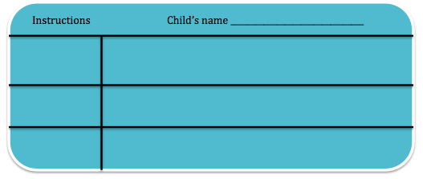

WHILE WE ARE OUT
Where we’ll be________________________
Time we’ll be home ____________________
How to reach us# ______________________________

Other contact in case of emergency
Name _______________________________
Number # ____________________________
Food
Bedtime
Other

Post self-assessment

I think my skills have improved as a result of completing this activity.

- Yes
- No

Learner comments:
________________________________________________________________________
_________________________________________________________________________________________________
_________________________________________________________________________________________________

Assessment
Task-Based Activity: Complete a babysitter information sheet
Learner Name: ______________________________ Date: ____________________________

Practitioner Name: _______________________________________

Performance Descriptors | Needs Work | Improving | Excellent
A1.1: Read brief texts to locate specific details reads short texts to locate a single piece of information
- decodes words and makes meaning of sentences in a single text
- follows the sequence of events in straightforward chronological texts
- follow simple, straightforward instructional texts
- identifies the main idea in brief texts
- requires support to identify sources and to evaluate and integrate information

B3.1a: Make straightforward entries to complete very simple documents
- makes a direct match between what is requested and what is entered
- makes entries using familiar vocabulary

The learner needs to work on the following:

This task was successfully completed ______ This task needs to be tried again ______

Practitioner Comments:

Learner Comments:

Task-Based Activity: Create a budget for a three-day vacation
Laubach Connection: Laubach Way to Reading (LWR) Book 3, Lesson 3
OALCF Link
Relevant Goal Paths
Employment, Independence
Rationale: Learners on the Employment and Independence Paths will need to create budgets for a variety of different reasons.

Task-Based Activity Description:
The learner will create a travel budget for a three-day trip.
Competency, Task Group and Level Indicators
(See Assessment page for performance descriptors)
B: Communicate Ideas and Information
B3: Complete and create documents
- B3.1a: Make straightforward entries to complete very simple documents

C: Understand and Use Numbers
C1: Manage money
- C1.1 Compare costs and make simple calculations

Materials Required
- Pen or pencil and eraser
- Question sheets

Overview
Activity Introduction
In lesson three, the Masons decide that they will go on a three-day trip at the end of the month. Discuss with the learner if they have ever created a budget for a short trip before. Discuss the importance of budgeting to be able to spend your money wisely and save money.

New words
Determine any new words that you think are being introduced in the activity and review those words with the learner.

Instructions
- Have the learner fill in their name and the date.
- Have the learner complete the pre self-assessment.
- Have the learner complete the task-based activity.
- After completing the activity, have the learner complete the post self-assessment.
- After the learner has completed the task-based activity, complete the assessment section and review the results with the learner.

Extension activities

- Compare the costs of different hotels online
- Calculate gas costs for a short trip

Task-Based Activity: Create a budget for a three-day vacation

Learner Name: _____________________________ Date: ____________________________

Pre self-assessment

I need to improve my skills at creating budgets:
- Yes
- No

Activity

Think of a place where you could go on a trip for three days. Prepare a budget for a three-day trip by estimating the cost of each item. After you have put in all the costs, add up the total estimated cost of the trip.

My Trip Budget
Travel Costs (gas and parking/bus or train)

Hotel or Accommodation Costs

Meal Costs

Other Costs (e.g. souvenirs)

Total Cost

Post self-assessment

I think my skills have improved as a result of completing this activity.
- Yes
- No

Learner comments:
_________________________________________________________________________________________________
_________________________________________________________________________________________________
_________________________________________________________________________________________________

Assessment
Task-Based Activity: Create a budget for a three-day vacation
Learner Name: ____________________________ Date: ____________________________

Practitioner Name: _______________________________________

Performance Descriptors | Needs Work | Improving | Excellent
B3.1a: Make straightforward entries to complete very simple documents
- makes a direct match between what is requested and what is entered
- makes entries using familiar vocabulary

C1.1: Compare costs and make simple calculations
- adds, subtracts, multiplies and divides whole numbers and decimals
- recognizes values in number and word format
- understands numerical order
- begins to interpret integers, such as in a negative bank balance
- identifies and performs required operation
- follows apparent steps to reach solutions
- interprets and represents costs using monetary symbols and decimals
- rounds to the nearest dollar
- uses strategies to check accuracy (e.g. estimating, using a calculator, repeating a calculation, using the reverse operation)

The learner needs to work on the following:

This task was successfully completed ______ This task needs to be tried again ______

Practitioner Comments:

Learner Comments:

Task-Based Activity: Use a table to determine the correct paint sheen
Laubach Connection: Laubach Way to Reading (LWR) Book 3, Lesson 4
OALCF Link
Relevant Goal Paths
Apprenticeship, Employment, Independence
Rationale: Learners on the Apprenticeship, Employment and Independence Paths will need to interpret information about products from tables for a variety of different reasons.

Task-Based Activity Description: The learner will review a table (paint sheen descriptions) to determine the correct type of paint to use for a variety of different reasons.
Competency, Task Group and Level Indicators
(See Assessment page for performance descriptors)
A: Find and Use Information
A2: Interpret documents
- A2.2 Interpret simple documents to locate and connect information

Materials Required
- Pen or pencil and eraser
- Question sheets

Overview
Activity Introduction
This task uses a table describing the different sheens for interior paint.

In lesson four, Jason and Gail decide to paint their apartment. Discuss with the learner if they have ever painted the inside of a house or apartment before. Discuss the importance of understanding how to interpret product information tables to be able to choose the correct product.

Note: If possible, obtain paint chips with the different sheens as a visual aid to this activity

New words
Determine any new words that you think are being introduced in the activity and review those words with the learner. Some suggested words are sheen, lustre, and versatile.

Instructions
- Have the learner fill in their name and the date.
- Have the learner complete the pre self-assessment.
- Have the learner complete the task-based activity.
- After completing the activity, have the learner complete the post self-assessment.
- After the learner has completed the task-based activity, complete the assessment section and review the results with the learner.
Extension activities
- Create and cost out a list of other materials you would need to paint
- Calculate the amount of paint you would need to paint a room
- Calculate the cost to paint a room

Task-Based Activity: Use a table to determine the correct paint sheen

Learner Name: ____________________________ Date: ____________________________

Pre self-assessment

I need to improve my skills at:
- Yes
- No

Activity
You are painting several different rooms in your house. Use the information in the table below to answer the questions.

Sheen | Description and Points to Consider | Recommended Rooms
Flat/Matte | - Provides a smooth, subtle finish  - Camouflages imperfections  - Ideal for low traffic areas  - Absorbs light  - Holds dirt and is more difficult to clean  - Rubbing with cleanser may burnish the finish | - Living room  - Dining room  - Bedroom  - Family Room  - Hallway
Eggshell/ Low-Lustre | - Offers an elegant, low-sheen finish  - Best for low traffic areas  - Smooth surface  - More washable than flat sheens | - Living room  - Dining Room  - Bedroom  - Family Room  - Hallway  - Kitchen  - Trim
Satin | - Can be wiped clean  - Provides an elegant finish  - Soft sheen reflects light  - Ideal for more active rooms  - Extremely versatile  - May be used indoors or outdoors | - Family Room  - Playroom  - Laundry Room  - Kitchen  - Guest bathroom  - Children's bedroom  - Trim  - Shutters  - Doors
Semi-Gloss |  | - Kitchen  - Bathroom  - Cabinets  - Doors  - Trim  - Moulding  - Hallway
  - Can be scrubbed clean with ease
  - Smooth sheen reflects light
  - Ideal for high traffic areas
  - Easy to wash
  - May be used indoors or outdoors
Gloss | - Can be scrubbed clean with ease  - Offers a smooth, high shine finish  - Ideal for surfaces that require frequent washing | - Trim  - Woodwork  - Moulding  - Doors  - Cabinets  - Kitchen  - Bath
Source of table: http://www.homedepot.ca/know-how/buying-guides/interior-paints

- What sheen of paint would you use to paint the shutters on your windows? ______________________________________

- What sheen would you use in your kitchen? _____________________________________________

- Why would your use gloss paint in your bathroom? Why or why not?

________________________________________________________________________
________________________________________________________________________

- What is the best sheen of paint to use when painting a child’s bedroom? ________________

Post self-assessment

I think my skills have improved as a result of completing this activity.
- Yes
- No

Learner comments:
______________________________________________________________________________
_____________________________________________________________________________
_____________________________________________________________________________

Assessment
Task-Based Activity: Use a table to determine the correct paint sheen
Learner Name: _____________________________ Date: ____________________________

Practitioner Name: _______________________________________

Performance Descriptors | Needs Work | Improving | Excellent
A2.2: Interpret simple documents to locate and connect information
- performs limited searches using one or two search criteria
- extracts information from tables and forms
- locates information in simple graphs and maps
- uses layout to locate information
- makes connections between parts of documents
- makes low-level inferences
- begins to identify sources and evaluate information

The learner needs to work on the following:

This task was successfully completed ______ This task needs to be tried again ______

Practitioner Comments:

Learner Comments:

Task-Based Activity: Review a wedding checklist
Laubach Connection: Laubach Way to Reading (LWR) Book 3, Lesson 5
OALCF Link
Relevant Goal Paths
Apprenticeship, Employment, Independence, Postsecondary, Secondary School Credit
Rationale: Learners on all of the goal paths will need to use lists for a variety of different reasons.

Task-Based Activity Description: The learner will interpret a simple document (wedding checklist) to locate specific details. The learner will make simple calculations using time to determine the correct month.
Competency, Task Group and Level Indicators
(See Assessment page for performance descriptors)
A: Find and Use Information
A2: Interpret documents
- A2.2 Interpret simple documents to locate and connect information

C. Understand and Use Numbers
C2: Manage time
- C2.1 Measure time and make simple comparisons and calculations

Materials Required
- Pen or pencil and eraser
- Question sheets

Overview
Activity Introduction
This task uses a wedding checklist.

In lesson five, Jason and Gail get married. Discuss with the learner if they are married or have ever been part of a wedding. Discuss the importance of using checklists when planning events or activities to make sure you don’t miss anything. Ask the learner if they use lists.

New words
Determine any new words that you think are being introduced in the activity and review those words with the learner.

Instructions
- Have the learner fill in their name and the date.
- Have the learner complete the pre self-assessment.
- Have the learner complete the task-based activity.
- After completing the activity, have the learner complete the post self-assessment.
- After the learner has completed the task-based activity, complete the assessment section and review the results with the learner.

Extension activities

- Create a variety of different to-do lists
- Use an online program to create a to-do list (e.g. OneNote)

Task-Based Activity: Review a wedding checklist

Learner Name: _____________________________ Date: ____________________________

Pre self-assessment

I need to improve my skills at using lists:
- Yes
- No

Activity
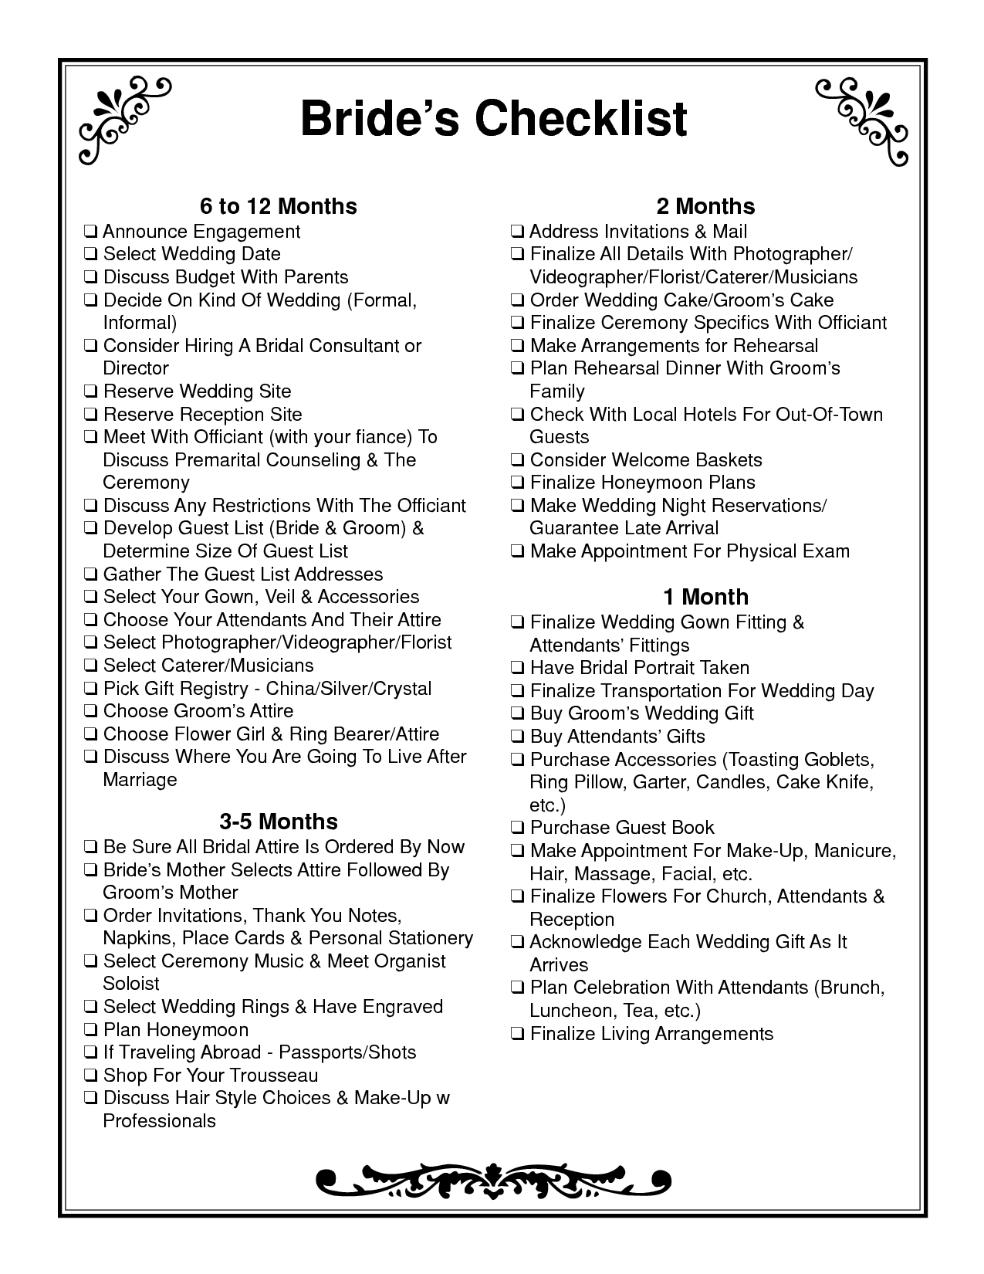
- When should you select a wedding date? ____________________________________

- If you are getting married in July, what month should you address and mail your wedding invitations? ________________________________________

- When is the best time to select a photographer for your wedding? ________________

_______________________________________________________________________

- What should you do if you are planning to go on a honeymoon abroad? ___________

_______________________________________________________________________

- What do you think are the three most important things to do 3-5 months before your wedding?

- __________________________________________________________________

- __________________________________________________________________

- __________________________________________________________________

- This checklist is for a bride. Is there anything missing from the list that a groom might need to do? ________________________________________________________________________

________________________________________________________________________

________________________________________________________________________

Post self-assessment

I think my skills have improved as a result of completing this activity.
- Yes
- No

Learner comments:
______________________________________________________________________________
______________________________________________________________________________
______________________________________________________________________________

Assessment
Task-Based Activity: Review a wedding checklist
Learner Name: _____________________________ Date: ____________________________

Practitioner Name: _______________________________________

Performance Descriptors | Needs Work | Improving | Excellent
A2.2: Interpret simple documents to locate and connect information
- performs limited searches using one or two search criteria
- extracts information from tables and forms
- locates information in simple graphs and maps
- uses layout to locate information
- makes connections between parts of documents
- makes low-level inferences
- begins to identify sources and evaluate information

C2.1: Measure time and make simple calculations
- adds, subtracts, multiplies and divides whole numbers and decimals
- recognizes values in number and word format
- understands chronological order
- understands and uses common date formats
- identifies and performs required operation
The learner needs to work on the following:

This task was successfully completed ______ This task needs to be tried again ______

Practitioner Comments:

Learner Comments:

Task-Based Activity: Wedding cake recipe
Laubach Connection: Laubach Way to Reading (LWR) Book 3, Lesson 6
OALCF Link
Relevant Goal Paths
Apprenticeship, Employment, Independence
Rationale: Learners on the Apprenticeship, Employment and Independence Paths will need to use recipes for a variety of different reasons.

Task-Based Activity Description: The learner will read a brief document (recipe) and make calculations to double the recipe.
Competency, Task Group and Level Indicators
(See Assessment page for performance descriptors)
A: Find and Use Information
A2: Interpret documents
- A2.2 Interpret simple documents to locate and connect information

C: Understand and Use Numbers
C3: Use Measures
- C3.2 Use measures to make one-step calculations

Materials Required
- Pen or pencil and eraser
- Question sheets

Overview
Activity Introduction
This task uses a wedding cake recipe.

Lesson six is a review lesson including the characters that were married in lesson five. Discuss with the learner if they use recipes to cook at home. Discuss the usefulness of recipes and the importance of understanding how to interpret them. Discuss the fact that even though we use the metric system in Canada most recipes are still written using imperial measurement.

New words
Determine any new words that you think are being introduced in the activity and review those words with the learner. Some suggested words to review: granulated, extract, parchment paper. You may also want to review measurement terms with the learner.

Instructions
- Have the learner fill in their name and the date.
- Have the learner complete the pre self-assessment.
- Have the learner complete the task-based activity.
- After completing the activity have the learner complete the post self-assessment.
- After the learner has completed the task-based activity complete the assessment section and review the results with the learner.

Extension activities
- Bring in a variety of different recipes for the learner to interpret.
- Have the learner bring in recipes from home that they are having difficulty understanding.

Task-Based Activity: Wedding cake recipe

Learner Name: _____________________________ Date: ____________________________

Pre self-assessment

I need to improve my skills at reading recipes:
- Yes
- No

Activity

Classic Wedding Cake Recipe
Ingredients
- 6 cups cake flour sifted
- 2 tablespoons baking powder
- 1 1/2 cups butter or margarine, softened
- 3 cups granulated sugar
- 2 cups milk
- 1 teaspoon pure vanilla extract
- 12 egg whites

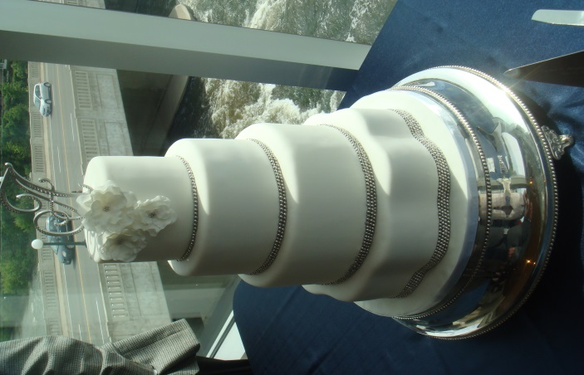

Makes
12 cups of cake batter
Instructions:
Step 1
Preheat oven to 325°F. Grease bottom of pans and line with waxed paper or parchment paper.
Step 2
Sift together flour and baking powder. Set aside. Cream butter and sugar together until light and fluffy. Set aside. Beat egg whites until stiff, but not dry. Set aside. With mixer at slow speed, add flour mixture to butter mixture, alternately with milk. Beat well after each addition. Beat in vanilla extract. Gently fold egg whites into batter. Pour into prepared pans. Bake until toothpick inserted into center comes out clean.

Source: http://www.wilton.com/recipe/Classic-White-Cake

- In order to make a wedding cake, you will need to double this recipe. How much butter or margarine will you need? __________________________________________

- If you double the recipe how much milk will you need? ______________________________

- How many dozen eggs do you need to buy if you double the recipe? __________________

- Circle, highlight or underline what you need to line the pans with.

- What temperature does the oven need to be set at to bake the cake? __________________

Post self-assessment

I think my skills have improved as a result of completing this activity.
- Yes
- No

Learner comments:
_________________________________________________________________________________________________
_________________________________________________________________________________________________
_________________________________________________________________________________________________

Assessment
Task-Based Activity: Wedding cake recipe
Learner Name: _____________________________ Date: ____________________________

Practitioner Name: _______________________________________

Performance Descriptors | Needs Work | Improving | Excellent
A2.2: Interpret simple documents to locate and connect information

- performs limited searches using one or two search criteria
- extracts information from tables and forms
- locates information in simple graphs and maps
- uses layout to locate information
- makes connections between parts of documents
- makes low-level inferences
- begins to identify sources and evaluate information

C3.2: Use measures to make one-step calculations
- calculates using numbers expressed as whole numbers, fractions, decimals, percentages and integers
- understands and uses ratio and proportion
- interprets and represents area and volume using symbols and abbreviations (e.g. m3)
- converts units of measurement within the same system and between systems
- chooses and performs required operation(s); may make inferences to identify required operation(s)
- selects appropriate steps to solutions
- interprets, represents and converts measures using whole numbers, decimals, percentages, ratios and simple, common fractions (e.g. ½, ¼)
- uses strategies to check accuracy (e.g. estimating, using a calculator, repeating a calculation, using the reverse operation)

The learner needs to work on the following:

This task was successfully completed ______ This task needs to be tried again ______

Practitioner Comments:

Learner Comments:

Task-Based Activity: Make a list of items for a first aid kit
Laubach Connection: Laubach Way to Reading (LWR) Book 3, Lesson 7
OALCF Link
Relevant Goal Paths
Apprenticeship, Employment, Independence, Postsecondary, Secondary School Credit
Rationale: Learners on all of the goal paths will need to make lists for a variety of different reasons.

Task-Based Activity Description: The learner makes a list of items that should be included in a basic first aid kit.
Competency, Task Group and Level Indicators
(See Assessment page for performance descriptors)
B: Communicate Ideas and Information
B3: Complete and create documents
- B3.1a: Make straightforward entries to complete very simple documents

Materials Required
- Pen or pencil and eraser
- Question sheets

Overview
Activity Introduction
This task uses a template to create a list for a First Aid kit.

In lesson eight, Lee gets into a car accident and cuts his face. Discuss with the learner if they have a basic first aid kit in their house. Discuss the importance of having some basic first aid items on hand. If there is a basic first aid kit available at the agency, the learner could use the kit to create the list. Ask the learner if they use lists and discuss how lists can help keep you organized or be used for shopping more efficiently.

New words
Determine any new words that you think are being introduced in the activity and review those words with the learner.

Instructions
- Have the learner fill in their name and the date.
- Have the learner complete the pre self-assessment.
- Have the learner complete the task-based activity.
- After completing the activity, have the learner complete the post self-assessment.
- After the learner has completed the task-based activity, complete the assessment section and review the results with the learner.
Extension activities
- Compare the list created with the actual contents of the First Aid kit at the agency
- Research online what should be contained in a First Aid kit
- Read about basic First Aid and CPR and find out where you can take a local course

Task-Based Activity: Make a list of items for a first aid kit

Learner Name: _____________________________ Date: ____________________________

Pre self-assessment

I need to improve my skills at making lists:
- Yes
- No

Activity

Every home and place of business should have a basic first aid kit. Make a list of all the items you think should be included in a basic first aid kit.
Basic First Aid Kit

- _____________________________________________________

- _____________________________________________________

- _____________________________________________________

- _____________________________________________________

- _____________________________________________________

- _____________________________________________________

- _____________________________________________________

- _____________________________________________________

- _____________________________________________________

- _____________________________________________________

- _____________________________________________________

- _____________________________________________________

- _____________________________________________________

- _____________________________________________________

- _____________________________________________________

- _____________________________________________________

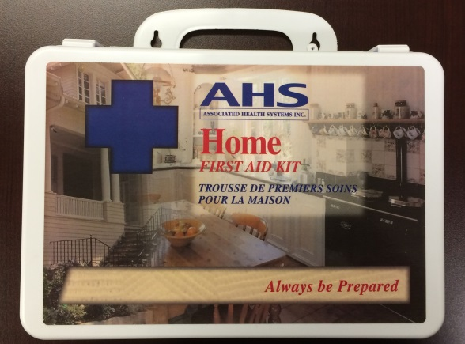
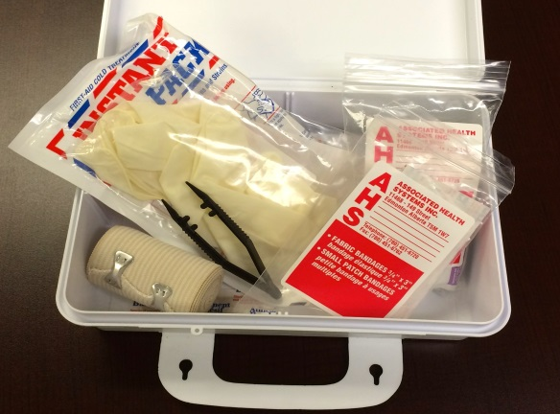

Post self-assessment

I think my skills have improved as a result of completing this activity.
- Yes
- No

Learner comments:
_____________________________________________________________________________
________________________________________________________________________________________________________
________________________________________________________________________________________________________

Assessment
Task-Based Activity: Make a list of items for a first aid kit
Learner Name: _____________________________ Date: ____________________________

Practitioner Name: _______________________________________

Performance Descriptors | Needs Work | Improving | Excellent
B3.1a: Make straightforward entries to complete very simple documents
- makes a direct match between what is requested and what is entered
- makes entries using familiar vocabulary

The learner needs to work on the following:

This task was successfully completed ______ This task needs to be tried again ______

Practitioner Comments:

Learner Comments:

Task-Based Activity: Use a grocery store flyer to plan purchases for a party
Laubach Connection: Laubach Way to Reading (LWR) Book 3, Lesson 8
OALCF Link
Relevant Goal Paths
Employment, Independence
Rationale: Learners on the Employment and Independence Paths may need to read flyers to make purchases for a variety of different reasons.

Task-Based Activity Description: The learner will read a document (grocery store advertisement) and make simple cost calculations.
Competency, Task Group and Level Indicators
(See Assessment page for performance descriptors)
A: Find and Use Information
A2: Interpret documents
- A2.1 Interpret very simple documents to locate specific details

C: Understand and Use Numbers
C1: Manage money
- C1.1 Compare costs and make simple calculations

Materials Required
- Pen or pencil and eraser
- Question sheets

Overview
Activity Introduction
This task uses a grocery store flyer.

In lesson eight, the class is having a party. Discuss with the learner whether they have ever planned a party before and if they use grocery store flyers to help them shop. Discuss with the learner the importance of using flyers to see what is on sale and possibly save money.

New words
Determine any new words that you think are being introduced in the activity and review those words with the learner.

Instructions
- Have the learner fill in their name and the date.
- Have the learner complete the pre self-assessment.
- Have the learner complete the task-based activity.
- After completing the activity have the learner complete the post self-assessment.
- After the learner has completed the task-based activity complete the assessment section and review the results with the learner.

Extension activities
- Use various flyers to compare prices of like items

Task-Based Activity: Use a grocery store flyer to plan purchases for a party

Learner Name: _____________________________ Date: ____________________________

Pre self-assessment

I need to improve my skills at:
- Yes
- No

Activity


You are planning a party for 12 people. You will be serving cheeseburgers, juice, and frozen treats. Use the flyer provided to help you calculate the costs for some of the items you will need.

- There are 12 frozen treats in a box of fudgsicles and 6 frozen treats in a box of vanilla ice cream sandwiches. If every guest has one frozen treat, what type of treat would be less expensive to serve? ________________________________________________________

- How much does each frozen juice usually cost (when it isn’t on sale)?________________

- If you estimate that you will need one frozen juice for every three guests, how many frozen juice should you purchase? ____________________________________________

- What will the total cost be if you buy one box of frozen treats, four frozen juices, two packs of buns, and one pack of cheese slices? __________________________________

Post self-assessment

I think my skills have improved as a result of completing this activity.
- Yes
- No

Learner comments:
_________________________________________________________________________________________________
_________________________________________________________________________________________________
________________________________________________________________________________________________

Assessment
Task-Based Activity: Use a grocery store flyer to plan purchases for a party
Learner Name: _____________________________ Date: ____________________________

Practitioner Name: _______________________________________

Performance Descriptors | Needs Work | Improving | Excellent
A2.1: Interpret very simple documents to locate specific details
- scans to locate specific details
- interprets brief text and common symbols
- locates specific details in simple documents, such as labels and signs
- identifies how lists are organized (e.g. sequential, chronological, alphabetical)
- requires support to identify sources and to evaluate and integrate information

C1.1: Compare costs and make simple calculations
- adds, subtracts, multiplies and divides whole numbers and decimals
- recognizes values in number and word format
- understands numerical order
- begins to interpret integers, such as in a negative bank balance
- identifies and performs required operation
- follows apparent steps to reach solutions
- interprets and represents costs using monetary symbols and decimals
- rounds to the nearest dollar
- uses strategies to check accuracy (e.g. estimating, using a calculator, repeating a calculation, using the reverse operation)
The learner needs to work on the following:

This task was successfully completed ______ This task needs to be tried again ______

Practitioner Comments:

Learner Comments:

Task-Based Activity: Fill in a warranty card
Laubach Connection: Laubach Way to Reading (LWR) Book 3, Lesson 9
OALCF Link
Relevant Goal Paths
Apprenticeship, Employment, Independence, Postsecondary, Secondary School Credit
Rationale: Learners on all the goal paths will need to complete simple information forms for a variety of different reasons.

Task-Based Activity Description: The learner will use an invoice to complete a simple form (warranty card).
Competency, Task Group and Level Indicators
(See Assessment page for performance descriptors)
B: Communicate Ideas and Information
B3: Complete and create documents
- B3.1a Make straightforward entries into very simple documents.

Materials Required
- Pen or pencil and eraser
- Question sheets

Overview
Activity Introduction
This task uses a warranty card for an appliance.

In lesson nine, Steve is saving his money to purchase a new television. Discuss with the learner if they have ever purchased a television or appliance before. Discuss the importance filling in the warranty that comes with the product to make sure you can get the product fixed or get your money back if there is a problem. Ask the learner if they have ever had any trouble filling in basic forms.

New words
Determine any new words that you think are being introduced in the activity and review those words with the learner.

Instructions
- Have the learner fill in their name and the date.
- Have the learner complete the pre self-assessment.
- Have the learner complete the task-based activity.
- After completing the activity have the learner complete the post self-assessment.
- After the learner has completed the task-based activity complete the assessment section and review the results with the learner.

Extension activities
- Address an envelope to send the warranty in

Task-Based Activity: Fill in a warranty card

Learner Name: _____________________________ Date: ____________________________

Pre self-assessment

I need to improve my skills at filling in forms:
- Yes
- No

Activity

Electronics Plus
123 Commerce Way
Anytown, AT
X4R 6Y5

22/12/2013

32 inch LED
Model 444-56
SN: 288613

$249.99
HST $32.50

$282.49

Have a nice day!
Steve Jones has purchased a new television. Use the information from the invoice to fill in the warranty card.

Electronics Plus

Customer Name ____________________________
Address _____________________________________ Model __________________
Serial NO. ___________________________________
Date of purchase ______/______/______
TV Cell Phone DVD
Electronics Plus
Computer Telephone Software

CUSTOMER WARRANTY CARD

Post self-assessment

I think my skills have improved as a result of completing this activity.
- Yes
- No

Learner comments:
_________________________________________________________________________________________________
_________________________________________________________________________________________________
_________________________________________________________________________________________________

Assessment
Task-Based Activity: Fill in a warranty card
Learner Name: _____________________________ Date: ____________________________

Practitioner Name: _______________________________________

Performance Descriptors | Needs Work | Improving | Excellent
B3:
- makes a direct match between what is requested and what is entered
- makes entries using familiar vocabulary

The learner needs to work on the following:

This task was successfully completed ______ This task needs to be tried again ______

Practitioner Comments:

Learner Comments:

Task-Based Activity: Interpret a hockey schedule
Laubach Connection:Laubach Way to Reading (LWR) Book 3, Lesson 10
OALCF Link
Relevant Goal Paths
Apprenticeship, Employment, Independence, Postsecondary, Secondary School Credit
Rationale: Learners on all the goal paths will need to interpret schedules for a variety of different reasons.

Task-Based Activity Description: The learner will interpret two hockey schedules to determine game times.
Competency, Task Group and Level Indicators
(See Assessment page for performance descriptors)
A: Find and Use Information
A2: Interpret documents
- A2.2 Interpret simple documents to locate and connect information

C: Understand and Use Numbers
C2: Manage time
- C2.1 Measure time and make simple comparisons and calculations

Materials Required
- Pen or pencil and eraser
- Question sheets

Overview
Activity Introduction
This task uses two television hockey game schedules.

Lesson 10 is about Pete. Pete owns a repair shop but as a young man he played hockey. Discuss with the learner if they have ever played hockey or like to watch hockey. Discuss the fact that hockey is considered a national pastime in Canada. Ask the learner if they ever had trouble reading schedules. Discuss the fact that schedules come in a variety of different formats.

New words
Determine any new words that you think are being introduced in the activity and review those words with the learner.

Instructions
- Have the learner fill in their name and the date.
- Have the learner complete the pre self-assessment.
- Have the learner complete the task-based activity.
- After completing the activity, have the learner complete the post self-assessment.
- After the learner has completed the task-based activity, complete the assessment section and review the results with the learner.

Extension activities
- Interpret online television listings

Task-Based Activity: Interpret a hockey schedule

Learner Name: _____________________________ Date: ____________________________

Pre self-assessment

I need to improve my skills at:
- Yes
- No

Activity
Sunday, April 13
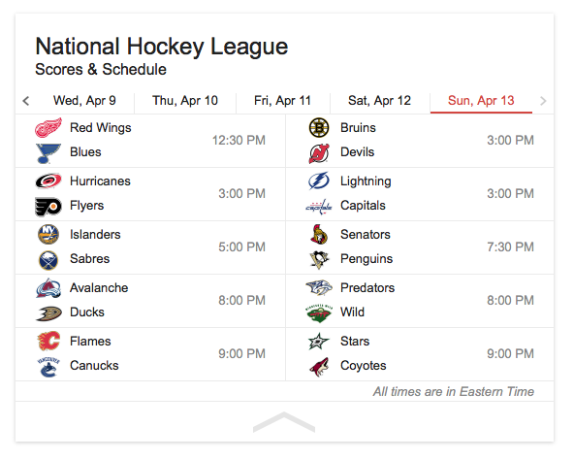

- What time are the Flames playing? __________________________________________

- What day and time are the Flyers playing? ____________________________________

- What team is playing against the Bruins on Sunday April 13th? ____________________

- If you want to watch the Penguins v. the Senators, what time do you need to turn your television on? ___________________________________________________________

- How many different games are there on Sunday April 13th? _______________________

- If you only watched the first ½ hour of as many games as possible on Sunday, April 13th, what is the maximum number of part games you could watch? ____________________

Post self-assessment

I think my skills have improved as a result of completing this activity.
- Yes
- No

Learner comments:
______________________________________________________________________________
______________________________________________________________________________
______________________________________________________________________________

Assessment
Task-Based Activity: Interpret a hockey schedule
Learner Name: ______________________________ Date: ____________________________

Practitioner Name: _______________________________________

Performance Descriptors | Needs Work | Improving | Excellent
A2.2: Interpret simple documents to locate and connect information
- performs limited searches using one or two search criteria
- extracts information from tables and forms
- uses layout to locate information
- makes connections between parts of documents
- makes low-level inferences
- begins to identify sources and evaluate information

C2.1: Measure time and make simple calculations
- adds, subtracts, multiplies and divides whole numbers and decimals
- recognizes values in number and word format
- identifies and performs required operation
- represents dates and times using standard conventions
- interprets and represents time using whole numbers, decimals (e.g. .25, .5) and simple common fractions (e.g. ½, ¼ hour)
- follows apparent steps to reach solutions

The learner needs to work on the following:

This task was successfully completed ______ This task needs to be tried again ______

Practitioner Comments:

Learner Comments:

Task-Based Activity: Research getting a driver’s licence
Laubach Connection: Laubach Way to Reading (LWR) Book 3, Lesson 11
OALCF Link
Relevant Goal Paths
Apprenticeship, Employment, Independence, Postsecondary, Secondary School Credit
Rationale: Learners on all of the goal paths will need to search for information on the Internet for a variety of different reasons.

Task-Based Activity Description: The learner finds a government website to research information about getting a driver’s licence in Ontario.
Competency, Task Group and Level Indicators
(See Assessment page for performance descriptors)
A: Find and Use Information
A1: Read continuous text
- A1.2: Read texts to locate and connect ideas and information
A2: Interpret documents
- A2.2: Interpret simple documents to locate and connect information

D: Use Digital Technology
- D.2 Perform well-defined, multi-step digital tasks

Materials Required
- Pen or pencil and eraser
- Internet access
- Question sheets

Overview
Activity Introduction
This task uses an Internet website (government) where the learner will look for information related to getting a licence in Ontario.

Lesson eleven is about getting a driver’s licence. Discuss with the learner if they have their driver’s licence. If not, discuss whether they want to get it. Discuss with them if they have any other family members that want to get their driver’s licence. Ask the learner if they have ever had any trouble finding information from a government website before.

New words
Determine any new words that you think are being introduced in the activity and review those words with the learner.

Instructions
- Have the learner fill in their name and the date.
- Have the learner complete the pre self-assessment.
- Have the learner complete the task-based activity.
- After completing the activity, have the learner complete the post self-assessment.
- After the learner has completed the task-based activity, complete the assessment section and review the results with the learner.

Extension activities
- Research the different steps to achieve each G licence level
- Compare the costs of different local driver’s education courses

Task-Based Activity: Research getting a driver’s licence

Learner Name: _____________________________ Date: ____________________________

Pre self-assessment

I need to improve my skills at searching the internet to obtain information:
- Yes
- No

Activity

Use the Internet to search for the Ontario Driving and Roads website. Once you have found the website, look for the information about getting a G driver’s licence and answer the following questions.

- How old do you have to be to apply for a G driver’s licence in Ontario? ___________________

- How many different types of licences are there in Ontario? _____________________________

- If you are a Canadian citizen can you use an Ontario Photo Card as an identity document?
_________________________________________________________________________________
4. Where can you apply for a G licence?
_________________________________________________________________________________
5. What is the address of your closest DriveTest Centre? __________________________________
__________________________________________________________________________________

Post self-assessment

I think my skills have improved as a result of completing this activity.
- Yes
- No

Learner comments:
______________________________________________________________________________
______________________________________________________________________________
______________________________________________________________________________

Assessment
Task-Based Activity: Research getting a driver’s licence
Learner Name: _____________________________ Date: ____________________________

Practitioner Name: _______________________________________

Performance Descriptors | Needs Work | Improving | Excellent
A1.2: Read texts to locate and connect ideas and information
- scans text to locate information
- locates multiple pieces of information in simple texts
- makes low-level inferences
- makes connections between sentences and between paragraphs in a single text
- reads more complex texts to locate a single piece of information
- follows the main events of descriptive, narrative and informational texts
- obtains information from detailed reading
- begins to identify sources and evaluate information

A2.2: Interpret simple documents to locate and connect information
- performs limited searches using one or two search criteria
- extracts information from tables and forms
- locates information in simple graphs and maps
- uses layout to locate information
- makes connections between parts of documents
- makes low-level inferences
- begins to identify sources and evaluate information

D.2: Perform well-defined, multi-step digital tasks
- selects and follows appropriate steps to complete tasks
- locates and recognizes functions and commands
- makes low-level inferences to interpret icons and text
- begins to identify sources and evaluate information
- performs simple searches using keywords (e.g. internet, software help menu)
The learner needs to work on the following:

This task was successfully completed ______ This task needs to be tried again ______

Practitioner Comments:

Learner Comments:

Task-Based Activity: Create a physical activity plan
Laubach Connection:Laubach Way to Reading (LWR) Book 3, Lesson 12
OALCF Link
Relevant Goal Paths
Independence
Rationale: Learners on the Independence Path may need to create a physical activity plan to maintain their health.

Task-Based Activity Description: The learner will read a brief text (tips for physical activity) to locate specific details and complete a simple form (physical activity plan).
Competency, Task Group and Level Indicators
(See Assessment page for performance descriptors)
A: Find and Use Information
A1: Read continuous text
- A1.2: Read texts to locate and connect ideas and information
B: Communicate Ideas and Information
B3: Complete and create documents
- B3.2a Use layout to determine where to make entries into simple documents

C: Understand and Use Numbers
C2: Use measures
- C2.1 Measure time and make simple comparisons and calculations
Materials Required
- Pen or pencil and eraser
- Question sheets

Overview
Activity Introduction

This task uses a short excerpt with tips about physical activity for adults and a blank physical activity plan template.

In lesson twelve, Fran is running. Discuss with the learner if theyexercise on a regular basis. Discuss the importance of exercise for health.

New words
Determine any new words that you think are being introduced in the activity and review those words with the learner. Suggested words include: moderate, vigorous, variety, template

Instructions
- Have the learner fill in their name and the date.
- Have the learner complete the pre self-assessment.
- Have the learner complete the task-based activity.
- After completing the activity, have the learner complete the post self-assessment.
- After the learner has completed the task-based activity, complete the assessment section and review the results with the learner.

Extension activities
- Make a list of all the “free” physical activities you can do locally
- Transfer the activity plan to a calendar format
- Create a healthy eating plan

Task-Based Activity: Create a physical activity plan

Learner Name: _____________________________ Date: ____________________________

Pre self-assessment

I need to improve my skills at reading information and completing forms:
- Yes
- No

Activity

Read the article “Physical Activity Tips for Adults (18-64 years). Answer the questions. After you have answered the questions, use the template to create a physical activity plan for one week.

Physical Activity Tips for Adults (18-64 years)
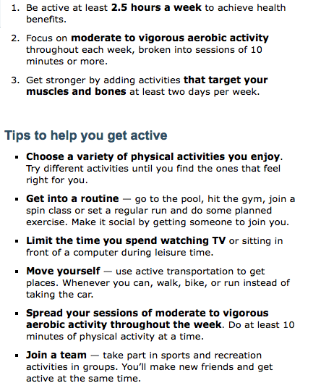
Source: http://www.phac-aspc.gc.ca/hp-ps/hl-mvs/pa-ap/07paap-eng.php

- Circle how many hours per week you should be active to achieve maximum health benefit.

- Calculate how many minutes per week you should be active. _____________________

- Record two tips that could help you get active.

__________________________________________________________________________________

___________________________________________________________________________
- Complete the template below to create a physical activity plan to maximum health benefit for one week.

Physical Activity Plan
Day of the week | Type of Exercise/Activity | Total Minutes

Post self-assessment

I think my skills have improved as a result of completing this activity.
- Yes
- No

Learner comments:
______________________________________________________________________________
______________________________________________________________________________
______________________________________________________________________________
Assessment
Task-Based Activity: Create a physical activity plan
Learner Name: _____________________________ Date: ____________________________

Practitioner Name: _______________________________________

Performance Descriptors | Needs Work | Improving | Excellent
A1:
- scans text to locate information
- locates multiple pieces of information in simple texts
- makes low-level inferences
- makes connections between sentences and between paragraphs in a single text
- obtains information from detailed reading

B3:
- uses layout to determine where to make entries
- begins to make some inferences to decide what information is needed, where and how to enter the information
- makes entries using a limited range of vocabulary

C2:
- identifies and performs required operation
- represents dates and times using standard conventions
- chooses appropriate units of measurement (e.g. hours, minutes, seconds)
- follows apparent steps to reach solutions

The learner needs to work on the following:
This task was successfully completed ______ This task needs to be tried again ______

Practitioner Comments:

Learner Comments:

Task-Based Activity: Interpret a Meeting agenda
Laubach Connection: Laubach Way to Reading (LWR) Book 3, Lesson 13
OALCF Link
Relevant Goal Paths
Apprenticeship, Employment, Independence, Postsecondary
Rationale: Learners on the Apprenticeship, Employment, Independence and Postsecondary Paths will need to understand meeting agendas for a variety of different reasons.

Task-Based Activity Description: The learner will interpret a simple document (meeting agenda) to locate and connect information.
Competency, Task Group and Level Indicators
(See Assessment page for performance descriptors)
A: Find and Use Information
A2: Interpret documents
- A2.2 Interpret simple documents to locate and connect information

Materials Required
- Pen or pencil and eraser
- Question sheets

Overview
Activity Introduction
This task uses a simple meeting agenda. Learners will locate information from themeeting agenda (includes a chart) using reading and layout.

New words
Determine any new words that you think are being introduced in the activity and review those words with the learner.

Instructions
- Have the learner fill in their name and the date.
- Have the learner complete the pre self-assessment.
- Have the learner complete the task-based activity.
- After completing the activity, have the learner complete the post self-assessment.
- After the learner has completed the task-based activity, complete the assessment section and review the results with the learner.

Extension activities
- Create a meeting agenda for an agency meeting

Task-Based Activity: Interpret a meeting agenda

Learner Name: ______________________________ Date: ____________________________

Pre self-assessment

I need to improve my skills at locating information in a simple document.
- Yes
- No

Activity
AGENDA
Colossal Marketing Semi-Annual Meeting
January 12, 2015
9:00 a.m. – 5:00 p.m.

Meeting called by Mr. Marcus Ricardo,
CEO and founder of Colossal Marketing

Attendees: All Colossal Marketing employees
Please read: Colossal Marketing: The New Manuel
Please bring: Pen or pencil and paper
9:00 a.m. – 10:00 a.m. | Introduction  Continental Breakfast Star Room  Welcome Lola Sturgen
10:00 a.m. – 12:00 p.m. | Company Presentation  New products for 2015 Clay M. GrasonBasco Room
12:00 p.m. – 1:00 p.m. | Lunch  Hot buffet Star Room
1:00 p.m. – 4:00 p.m. | Demos  Sales Techniques Grant Holward Basco Room  Consumer Statistics Lisa Petersen Spring Room  Advertising to Teens Clara JinStar Room
4:00 p.m. – 5:00 p.m. | Wrap-up  Q&A Panel All speakers Star Room

Additional Instructions:

During the demo portion of the meeting, feel free to explore all the presentations. Each speaker will be presenting three times.
- Who called the meeting and what is their position at the company?

______________________________________________________________________________
______________________________________________________________________________

- When is the meeting? (date and time)

______________________________________________________________________________
- In what room do the majority of the events take place? _________________________________

- How many meals are included at the meeting? ________________________________________

- What are you encouraged to do during the demos section of the meeting?

______________________________________________________________________________
______________________________________________________________________________
______________________________________________________________________________
- What is the company’s presentation about and who is speaking?

______________________________________________________________________________
______________________________________________________________________________

Post self-assessment

I think my skills have improved as a result of completing this activity.
- Yes
- No

Learner comments:
______________________________________________________________________________
______________________________________________________________________________
______________________________________________________________________________

Assessment
Task-Based Activity: Interpret a meeting agenda
Learner Name: ___________________________ Date: _________________________

Practitioner Name: _______________________________________

Performance Descriptors | Needs Work | Improving | Excellent
A2.2: Interpret simple documents to locate and connect information
- performs limited searches using one or two search criteria
- extracts information from tables and forms
- uses layout to locate information
- makes connections between parts of documents
- makes low-level inferences
- begins to identify sources and evaluate information

The learner needs to work on the following:

This task was successfully completed ____ This task needs to be tried again ____

Practitioner Comments:

Learner Comments:

Task-Based Activity: Interpret a flight price table
Laubach Connection: Laubach Way to Reading (LWR) Book 3, Lesson 14
OALCF Link
Relevant Goal Paths
Apprenticeship, Employment, Independence, Postsecondary, Secondary School Credit
Rationale: Learners on the Apprenticeship, Employment and Independence Paths will need to read tables with flight pricesfor a variety of different reasons.

Task-Based Activity Description: The learner will interpret a simple document (flight price table) to locate and connect information (A2.2).
Competency, Task Group and Level Indicators
(See Assessment page for performance descriptors)
A: Find and Use Information
A2: Interpret documents
- A2.2: Interpret simple documents to locate and connect information

Materials Required
- Pen or pencil and eraser
- Question sheets

Overview
Activity Introduction
This task uses a table with flight prices. The learner will examine the table and use its contents to answer the questions.

New words
Determine any new words that you think are being introduced in the activity and review those words with the learner.

Instructions
- Have the learner fill in their name and the date.
- Have the learner complete the pre self-assessment.
- Have the learner complete the task-based activity.
- After completing the activity, have the learner complete the post self-assessment.
- After the learner has completed the task-based activity, complete the assessment section and review the results with the learner.

Extension activities
- Bring in a variety of different labels for the learner to interpret.
- Have the learner bring in labels from home that they are having difficulty understanding.

Task-Based Activity: Interpret a flight price table

Learner Name: _____________________________ Date: ____________________________

Pre self-assessment

I need to improve my skills at locating information in tables:
- Yes
- No

Activity
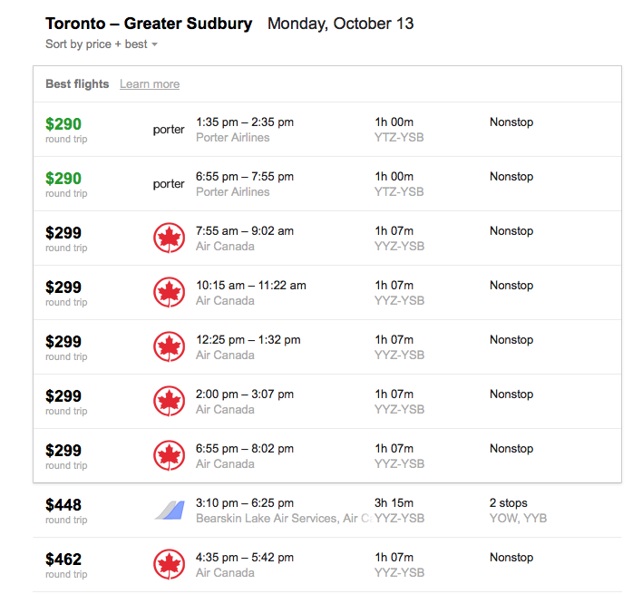

- Where do these flights leave from and go to? __________________________________________________________________
- You need to be in Sudbury by 2:40 pm. Which flight should you take? __________________________________________________________________

- Which company provides the cheapest flight? __________________________________________________________________

- Which company stops twice on the way to Sudbury? __________________________________________________________________
- How long is the shortest flight? __________________________________________________________________
- Based on price, times, and number of stops, choose the best flight for you to take a trip from Toronto to Sudbury. Explain. ________________________________________________________________________________________________________________________________________________________________________________________________________________________________________________________________________

Post self-assessment
I think my skills have improved as a result of completing this activity.
- Yes
- No
Learner comments:
______________________________________________________________________________
______________________________________________________________________________
______________________________________________________________________________

Assessment
Task-Based Activity: Interpret a flight price table
Learner Name: ____________________________ Date: ____________________________

Practitioner Name: _______________________________________

Performance Descriptors | Needs Work | Improving | Excellent
A2.2: Interpret simple documents to locate and connect information
- performs limited searches using one or two search criteria
- extracts information from tables and forms
- locates information in simple graphs and maps
- uses layout to locate information
- makes connections between parts of documents
- makes low-level inferences
- begins to identify sources and evaluate information
The learner needs to work on the following:

This task was successfully completed ______ This task needs to be tried again ______

Practitioner Comments:

Learner Comments:

Task-Based Activity: Used car advertisement
Laubach Connection: Laubach Way to Reading (LWR) Book 3, Lesson 15
OALCF Link
Relevant Goal Paths
Employment, Independence
Rationale: Learners on the Employment and Independence Paths will need to read advertisements and make calculations for a variety of different reasons.

Task-Based Activity Description: The learner will read an advertisement for a used car and make calculations based on the information provided.
Competency, Task Group and Level Indicators
(See Assessment page for performance descriptors)
A: Find and Use Information
A2: Interpret documents
- A2.2: Interpret simple documents to locate and connect information

C: Understand and Use Numbers
C1: Manage money
- C1.2: Make low-level inferences to calculate costs and expenses that may include rates such as taxes and discounts

Materials Required
- Pen or pencil and eraser
- Question sheets

Overview
Activity Introduction

This task uses an advertisement for a used car.

In lesson fifteen, Jill is learning to drive. Discuss with the learner if they drive and have ever purchased a vehicle before. Discuss the importance of understanding how to calculate payments if you are purchasing an item like a car. Ask the learner if they have ever had any trouble reading advertisements before.

New words
Determine any new words that you think are being introduced in the activity and review those words with the learner.

Instructions
- Have the learner fill in their name and the date.
- Have the learner complete the pre self-assessment.
- Have the learner complete the task-based activity.
- After completing the activity, have the learner complete the post self-assessment.
- After the learner has completed the task-based activity, complete the assessment section and review the results with the learner.

Extension activities
- Bring in a variety of different “for sale” advertisements for the learner to interpret
- Have the learner look up new cars on the Internet to determine cost and monthly payments

Task-Based Activity:

Learner Name: _____________________________ Date: ____________________________

Pre self-assessment

I need to improve my skills at reading advertisements and making calculations:
- Yes
- No

Activity

For Sale: 2008 Sedan
4 cyl engine  5 speed automatic transmission  New all season tires  Tinted glass  Reclining front bucket seats  AM/FM stereo with CD player  Steering wheel radio controls  Air conditioning  Cruise control  Price $6,000.00  0% Financing over 10 months with minimum 10% down payment | Cars R Us
 | Cars R Us

- Circle or highlight the name of the company selling the car.

- What type of transmission does the car have? ________________________________________

You have saved up to 10% of the cost of the car for the down payment. You can pay the rest off in 10 equal monthly payments.

- How much is your down payment? ________________________________________________

- How much is your monthly payment? ______________________________________________

- The car will lose 25% of its value the first year you own it. How much will it be worth after one year? ___________________________________________

Post self-assessment

I think my skills have improved as a result of completing this activity.
- Yes
- No

Learner comments:
______________________________________________________________________________
______________________________________________________________________________
______________________________________________________________________________

Assessment
Task-Based Activity:
Learner Name: _____________________________ Date: ____________________________

Practitioner Name: _______________________________________

Performance Descriptors | Needs Work | Improving | Excellent
A2:
- performs limited searches using one or two search criteria
- extracts information from tables and forms
- uses layout to locate information
- makes low-level inferences

C1:
- calculates using numbers expressed as whole numbers, fractions, decimals, percentages and integers
- calculates percentages
- chooses and performs required operation(s); may make inferences to identify required operation(s)
- selects appropriate steps to reach solution
- represents costs and rates using monetary symbols, decimals and percentages
- uses strategies to check accuracy (e.g. estimating, using a calculator, repeating a calculation, using the reverse operation)
The learner needs to work on the following:

This task was successfully completed ______ This task needs to be tried again ______

Practitioner Comments:

Learner Comments:

Task-Based Activity: Complete a home inventory list
Laubach Connection: Laubach Way to Reading (LWR) Book 3, Lesson 16
OALCF Link
Relevant Goal Paths
Apprenticeship, Employment, Independence
Rationale: Learners on the Apprenticeship, Employment and Independence Paths will need to create inventory lists for a variety of different reasons.

Task-Based Activity Description: The learner will create a home inventory list.
Competency, Task Group and Level Indicators
(See Assessment page for performance descriptors)
B: Communicate Ideas and Information
B3: Complete and create documents
- B3.1a: Make straightforward entries into very simple documents

Materials Required
- Pen or pencil and eraser
- Question sheets

Overview
Activity Introduction
This task-based activity uses a blank home inventory template.

In lesson sixteen, Tony comes home to find he has had a break-in. Discuss with the learner if they have ever been robbed or know someone that has been robbed before. Discuss the importance of having an up-to-date list of your belongings in case you need to make an insurance claim. Ask the learner if they have ever had any trouble filling in a chart before. Note: The learner will likely need to complete this activity at home.

New words
Determine any new words that you think are being introduced in the activity and review those words with the learner.

Instructions
- Have the learner fill in their name and the date.
- Have the learner complete the pre self-assessment.
- Have the learner complete the task-based activity. They will likely have to take the activity home to fully complete it.
- After completing the activity, have the learner complete the post self-assessment.
- After the learner has completed the task-based activity, complete the assessment section and review the results with the learner.

Extension activities
- Use a free online inventory program to keep track of your valuables

Task-Based Activity: Complete a home inventory list

Learner Name: ________________________________ Date: __________________________

Pre self-assessment

I need to improve my skills at:
- Yes
- No

Activity
HOME INVENTORY________________________________________________________

Address:
Name:
No. | Room where located | Item | Brand/Model | Purchase Price | Purchase Date | Purchase Store | Serial Number/ID | Notes

Post self-assessment

I think my skills have improved as a result of completing this activity.
- Yes
- No

Learner comments:
______________________________________________________________________________
______________________________________________________________________________

Assessment
Task-Based Activity: Complete a home inventory list
Learner Name: _____________________________ Date: ____________________________

Practitioner Name: _______________________________________

Performance Descriptors | Needs Work | Improving | Excellent
B3.1a: Make straightforward entries to complete very simple documents
- makes a direct match between what is requested and what is entered
- makes entries using familiar vocabulary
The learner needs to work on the following:

This task was successfully completed ______ This task needs to be tried again ______

Practitioner Comments:

Learner Comments:

Task-Based Activity: Fire Evacuation Plan
Laubach Connection: Laubach Way to Reading (LWR) Book 3, Lesson 17
OALCF Link
Relevant Goal Paths
Employment, Independence
Rationale: Learners on the Employment and Independence Paths may need to create a fire evacuation plan to ensure their safety and the safety of others.

Task-Based Activity Description: The learner will create a fire evacuation plan on the template provided.
Competency, Task Group and Level Indicators
(See Assessment page for performance descriptors)
A: Find and Use Information
A1: Read continuous text
- A1.1: Read a brief text to locate specific details

B: Communicate Ideas and Information
B3: Complete and create documents
- B3.2b: Create simple documents to sort, display and organize information

Materials Required
- Pen or pencil and eraser
- Question sheets

Overview: Fire Evacuation Plan
Activity Introduction
This task uses blank graph paper for the learner to create an evacuation plan. A description and sample plan are provided.

In lesson seventeen, a fire is described. Discuss with the learner if they or any close friends or relatives have ever experienced a house fire before. Discuss the importance of having an evacuation plan in place in case of a fire.

New words
Determine any new words that you think are being introduced in the activity and review those words with the learner.

Instructions
1. Have the learner fill in their name and the date.
- Have the learner complete the pre self-assessment.
- Have the learner complete the task-based activity.
- After completing the activity, have the learner complete the post self-assessment.
- After the learner has completed the task-based activity, complete the assessment section and review the results with the learner.
Extension activities
- Create a basic floor plan of the agency

Task-Based Activity: Fire Evacuation Plan

Learner Name: ____________________________ Date: ____________________________

Pre self-assessment

I need to improve my skills at drawing diagrams.
- Yes
- No

Activity

Having a home evacuation plan is very important. You need to make sure you have:
- A floor plan of your home that shows two ways out of every room, including windows.
- Approved collapsible ladders to escape from upper story windows.
- A plan to practice escaping from every room in the home. Make sure everyone understands the escape plan. You should practice your plan at least twice per year. Make sure that everyone who lives in your home practices the plan.
- Teach children not to hide from firefighters.
- An outside meeting place where everyone will gather after you have escaped.

Sample Evacuation Plan
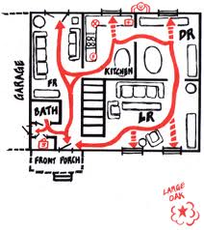
Create an Evacuation Plan

- Draw a rough floor plan of your home using the grid paper provided on the next page.

- If your home has more than one story use two pieces of grid paper.

- Use arrows to show two ways out of every room.

- Windows that open can be used as a way out of a room.

- Show all the doors and windows.

- Include a meeting place that is outside of your home on your evacuation plan.



Post self-assessment

I think my skills have improved as a result of completing this activity.
- Yes
- No

Learner comments:
____________________________________________________________________________________________________________________________________________________________
______________________________________________________________________________

Assessment
Task-Based Activity: Fire Evacuation Plan
Learner Name: ____________________________ Date: ______________________

Practitioner Name: _______________________________________

Performance Descriptors | Needs Work | Improving | Excellent
A1.1: Read brief texts to locate specific details
- reads short texts to locate a single piece of information
- decodes words and makes meaning of sentences in a single text
- follows the sequence of events in straightforward chronological texts
- follow simple, straightforward instructional texts
- identifies the main idea in brief texts
- requires support to identify sources and to evaluate and integrate information

B3.2b: Create simple documents to sort, display and organize information
- follows conventions to display information in simple documents (e.g. use of font, colour, shading, bulleted lists)
- sorts entries into categories
- displays one or two categories of information organized according to content to be presented
- identifies parts of documents using titles, row and column headings and labels

The learner needs to work on the following:

This task was successfully completed ______ This task needs to be tried again ______

Practitioner Comments:

Learner Comments:

Task-Based Activity: Campsite Prices
Laubach Connection: Laubach Way to Reading (LWR) Book 3, Lesson 18
OALCF Link
Relevant Goal Paths
Apprenticeship, Employment, Independence
Rationale: Learners on theApprenticeship, Employment andIndependencePaths will need to book and price vacations/ venues for a variety of different reasons.

Task-Based Activity Description:The learner will read a brief text (campsite description) to locate specific details (A1.1) and interpret a simple document (price chart) to locate information (A2.2). The learner will use calculations to determine and compare costs (C1.1).
Competency, Task Group and Level Indicators
(See Assessment page for performance descriptors)
A: Find and Use Information
A1: Read continuous text
- A1.1 Read brief texts to locate specific details
A2: Interpret documents
- A2.2 Interpret simple documents to locate and connect information
C: Understand and Use Numbers
C1: Manage money
- C1.1 Compare costs and make simple calculations

Materials Required
- Pen or pencil and eraser
- Question sheets
- Calculator

Overview
Activity Introduction
This task uses a price chart and text describing the prices of different campsites in national Canadian parks. Learners will read and analyze the provided information and answer the questions. They are allowed to use a calculator to check their answers if the question requires calculations.

New words
Determine any new words that you think are being introduced in the activity and review those words with the learner.

Instructions
- Have the learner fill in their name and the date.
- Have the learner complete the pre self-assessment.
- Have the learner complete the task-based activity.
- After completing the activity, have the learner complete the post self-assessment.
- After the learner has completed the task-based activity, complete the assessment section and review the results with the learner.

Extension activities
- Have learners prepare an email or a phone call to book a campsite and ask specific questions.

Task-Based Activity: Campsite Prices

Learner Name: _________________________________ Date: _________________________

Pre self-assessment

I need to improve my skills at making calculations and comparing prices.
- Yes
- No

Activity
Camping Fees 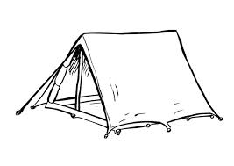
Provincial Parks offers everything from tent and trailer camping in organized campgrounds to wilderness campsites accessible only by canoe. Fees for camping vary according to the facilities and services provided.
Provincial Parks has three levels of fees for camping - premium, middle and low. Each fee level reflects the popularity of a campsite and the availability of facilities such as flush toilets and showers, and personal services such as educational programs.
When registering in person at the park you may use your debit card, cash, VISA, MasterCard or American Express credit cards to pay for your camping fees. Sorry, but personal cheques are not accepted for in-person payments.
Fees for camping and operating dates for individual provincial parks are subject to change. The fees listed below are per campsite per night.

A - Premium | Base Fee | Tax | Total
Electrical | $43.75 | $5.69 | $49.44
Non-electrical | $38.25 | $4.97 | $43.22
Non-electrical without showers | $37.00 | $4.81 | $41.81
B- Middle | Base Fee | Tax | Total
Electrical | $40.00 | $5.20 | $45.20
Non-electrical | $35.00 | $4.55 | $39.55
Non-electrical without showers | $33.75 | $4.39 | $38.14
C - Low | Base Fee | Tax | Total
Electrical | $35.00 | $4.55 | $39.55
Non-electrical | $30.50 | $3.97 | $34.47
Non-electrical without showers | $28.75 | $3.74 | $32.49

1. If you wanted to camp in a site that has electricity, what are the three prices per night you could choose from? __________________, __________________, __________________
2. What would a low, non-electrical campsite cost if you wanted to stay for two days? ____________________
3. Circle, underline or highlight the accepted methods of payment.
4. How much is the tax per night for a low, non-electrical campsite? _______________
5. What would be the total cost of a two-day vacation if you wanted to stay at a middle level campsite without electrical or showers the first night, and a premium, non-electrical campsite the second night? ________________________________
6. How much more per night is a premium campsite with electricity than a premium campsite without electricity? ___________________________

Post self-assessment
I think my skills have improved as a result of completing this activity.
- Yes
- No

Learner comments:
______________________________________________________________________________
______________________________________________________________________________
______________________________________________________________________________

Assessment
Task-Based Activity: Campsite Prices
Learner Name: __________________________ Date: _______________________

Practitioner Name: _______________________________________

Performance Descriptors | Needs Work | Improving | Excellent
A1.1: Read brief texts to locate specific details
- reads short texts to locate a single piece of information
- decodes words and makes meaning of sentences in a single text
- follows the sequence of events in straightforward chronological texts
- follow simple, straightforward instructional texts
- identifies the main idea in brief texts
- requires support to identify sources and to evaluate and integrate information

A2.2: Interpret simple documents to locate and connect information
- performs limited searches using one or two search criteria
- extracts information from tables and forms
- uses layout to locate information
- makes connections between parts of documents
- makes low-level inferences
- begins to identify sources and evaluate information

C1.1: Compare costs and make simple calculations
- adds, subtracts, multiplies and divides whole numbers and decimals
- recognizes values in number and word format
- understands numerical order
- identifies and performs required operation
- follows apparent steps to reach solutions
- interprets and represents costs using monetary symbols and decimals
- rounds to the nearest dollar
- uses strategies to check accuracy (e.g. estimating, using a calculator, repeating a calculation, using the reverse operation)

The learner needs to work on the following:

This task was successfully completed ____This task needs to be tried again ____

Practitioner Comments:

Learner Comments:

Task-Based Activity: Comparing tires
Laubach Connection: Laubach Way to Reading (LWR) Book 3, Lesson 19
OALCF Link
Relevant Goal Paths
Apprenticeship, Employment, Independence, Postsecondary, Secondary School Credit
Rationale: Learners on all the goal paths will need to be able to extract information from videos for a variety of different reasons.
Task-Based Activity Description: The learner will search for an online video (D2), watch the video to find out information (A3) and write a short paragraph (B2.1).
Competency, Task Group and Level Indicators
(See Assessment page for performance descriptors)
A: Find and Use Information
- A3: Extract information from films, broadcasts and presentations
B: Communicate Ideas and Information
- B2.1: Write brief texts to convey simple ideas and factual information
D: Use Digital Technology
- D2: Perform well-defined, multi-step digital tasks

Materials Required
- Pen or pencil and eraser
- Question sheets
- Internet access

Overview
Activity Introduction
This task uses an online video.
In lesson nineteen, Sam is driving in the snow. Discuss with the learner if they have ever driven in bad weather. Discuss the importance of having good tires. Ask the learner if they have ever purchased tires for a vehicle before.

New words
Determine any new words that you think are being introduced in the activity and review those words with the learner.

Instructions
- Have the learner fill in their name and the date.
- Have the learner complete the pre self-assessment.
- Have the learner complete the task-based activity.
- After completing the activity have the learner complete the post self-assessment.
- After the learner has completed the task-based activity complete the assessment section and review the results with the learner.

Extension activities
- Choose another topic of interest to the learner and do the same activity
- Create a table comparing features and prices for different types of tires

Task-Based Activity: Comparing tires

Learner Name: ___________________________ Date: ____________________________

Pre self-assessment

I need to improve my skills at understanding information from videos and writing short paragraphs:
- Yes
- No

Activity

 Search for a video about winter tires versus all-season tires on the Internet.

Watch the video and decide which type of tires would be best for you to purchase for the winter.

Write a short paragraph describing which type of tires you would choose and why.

Post self-assessment

I think my skills have improved as a result of completing this activity.
- Yes
- No

Learner comments:
______________________________________________________________________________
______________________________________________________________________________
______________________________________________________________________________

Assessment
Task-Based Activity: Comparing Tires
Learner Name: ___________________________ Date: ____________________________

Practitioner Name: _______________________________________

Performance Descriptors | Needs Work | Improving | Excellent
B2.1: Write brief texts to convey simple ideas and factual information
- writes simple texts to request, remind or inform
- conveys simple ideas and factual information
- demonstrates a limited understanding of sequence
- uses sentence structure, upper and lower case and basic punctuation
- uses highly familiar vocabulary

D2: Perform well-defined, multi-step digital tasks
- selects and follows appropriate steps to complete tasks
- locates and recognizes functions and commands
- makes low-level inferences to interpret icons and text
- begins to identify sources and evaluate information
- performs simple searches using keywords (e.g. internet, software help menu)
The learner needs to work on the following:

This task was successfully completed ______ This task needs to be tried again ______

Practitioner Comments:

Learner Comments:

Task-Based Activity: Retail Job Advertisement
Laubach Connection: Laubach Way to Reading (LWR) Book 3, Lesson 20
OALCF Link
Relevant Goal Paths
Apprenticeship, Employment, Independence, Postsecondary
Rationale: Learners on the Apprenticeship, Employment, Independence and Postsecondary Paths will need to read job advertisements for a variety of different reasons.

Task-Based Activity Description: The learner will interpret a document (job description) to locate specific details (A2.1).
Competency, Task Group and Level Indicators
(See Assessment page for performance descriptors)
A: Find and Use Information
A2: Read continuous text
- A2.1 Interpret very simple documents to locate specific details
Materials Required
- Pen or pencil and eraser
- Question sheets

Overview
Activity Introduction
This task uses a retail job advertisement. The learner will read the advertisement and locate specific details to answer the questions.

New words
Determine any new words that you think are being introduced in the activity and review those words with the learner.

Instructions
- Have the learner fill in their name and the date.
- Have the learner complete the pre self-assessment.
- Have the learner complete the task-based activity.
- After completing the activity, have the learner complete the post self-assessment.
- After the learner has completed the task-based activity, complete the assessment section and review the results with the learner.

Extension activities
- Have learner write a mock email to Maureen’s & Matt’s with their resume attached
- Have learner participate in a mock job interview

Task-Based Activity: Retail Jobs Advertisement

Learner Name: ____________________________ Date: __________________________

Pre self-assessment

I need to improve my skills at:
- Yes
- No

Activity
Job Overview 
Position: PT Sales Associate
Position Type: Part Time
Location: Maureen’s & Matt’s
Job Description
Maureen's and Matt’s is looking for a fashion-loving, sales-driven, enthusiastic team player to join their team.
Availability: Evenings and weekends. Apply in store or by email: jobs@maureensandmatts.ca
Required Skills
- Retail experience an asset, but not required.
Job Contact Information
Contact Name: Maureen Springer or Matt Lowe
Phone: 555-555-5555

- Who should you contact about the job? _______________________________________

- Circle, underline or highlight words that describe what type of job this is.

- How can you apply? _______________________________________________________

- What kind of a person are they looking for?

________________________________________________________________________

________________________________________________________________________

- When would you have to be available to get this job?

________________________________________________________________________

- To check up on your application, what phone number would you use?

_______________________________________________

Post self-assessment

I think my skills have improved as a result of completing this activity.
- Yes
- No

Learner comments:
______________________________________________________________________________
______________________________________________________________________________
______________________________________________________________________________

Assessment
Task-Based Activity: Retail Job Advertisement
Learner Name: ______________________________ Date: _________________________

Practitioner Name: _______________________________________

Performance Descriptors | Needs Work | Improving | Excellent
A2.1 Interpret very simple documents to locate specific details
- scans to locate specific details
- interprets brief text and common symbols
- identifies how lists are organized (e.g. sequential, chronological, alphabetical)
- requires support to identify sources and to evaluate and integrate information

The learner needs to work on the following:

This task was successfully completed ____ This task needs to be tried again ____

Practitioner Comments:

Learner Comments:

Task-Based Activity: Research the smokers’ helpline
Laubach Connection: Laubach Way to Reading (LWR) Book 3, Lesson 21
OALCF Link
Relevant Goal Paths
Apprenticeship, Employment, Independence, Postsecondary, Secondary School Credit
Rationale: Learners on the all the goal paths will need to read advertisements and conduct research on the Internet for a variety of different reasons.
Task-Based Activity Description: The learner will look at a document (newspaper advertisement) and look up a website on the Internet to get information about the smokers’ helpline.
Competency, Task Group and Level Indicators
(See Assessment page for performance descriptors)
A: Find and Use Information
A1: Read continuous text
- A1.1: Read brief texts to locate specific details
A2: Interpret documents
- A2.1: Interpret very simple documents to locate specific details

D: Use Digital Technology
- D2: Perform well-defined, multi-step digital tasks

Materials Required
- Pen or pencil and eraser
- Question sheets

Overview
Activity Introduction
This task uses a newspaper advertisement and an Internet website.

In lesson twenty-one, the learner reads about Joe who has quit smoking. Discuss with the learner if they have ever know anyone who has tried to quit smoking before. Discuss the importance of having support if someone is trying to quit. Ask the learner if they have ever heard of the smokers’ helpline.

New words
Determine any new words that you think are being introduced in the activity and review those words with the learner.

Instructions
- Have the learner fill in their name and the date.
- Have the learner complete the pre self-assessment.
- Have the learner complete the task-based activity.
- After completing the activity, have the learner complete the post self-assessment.
- After the learner has completed the task-based activity, complete the assessment section and review the results with the learner.

Extension activities
- Make a list of strategies you can use to quit smoking

Task-Based Activity: Research the smokers’ helpline

Learner Name: __________________________ Date: ____________________________

Pre self-assessment

I need to improve my skills at reading ads and reading information on the Internet:
- Yes
- No

Activity

Search for the smokers’ helpline website on the Internet. Look under “quit program”. Use the newspaper advertisement provided and the information on the website to answer the following questions.

- What is the number to call for smokers’ helpline? _______________________________

- What are the three ways you can get help from smokers’ helpline? ________________

___________________________________________________________________________

3. How much does it cost to use smokers’ helpline? ________________________________

Post self-assessment

I think my skills have improved as a result of completing this activity.
- Yes
- No

Learner comments:
______________________________________________________________________________
______________________________________________________________________________
______________________________________________________________________________

Assessment
Task-Based Activity: Research the smokers’ helpline
Learner Name: _____________________________ Date: ____________________________

Practitioner Name: _______________________________________

Performance Descriptors | Needs Work | Improving | Excellent
A1.1: Read brief texts to locate specific details
- reads short texts to locate a single piece of information
- decodes words and makes meaning of sentences in a single text
- follows the sequence of events in straightforward chronological texts
- follow simple, straightforward instructional texts
- identifies the main idea in brief texts
- requires support to identify sources and to evaluate and integrate information

A2.1: Interpret very simple documents to locate specific details
- scans to locate specific details
- interprets brief text and common symbols
- locates specific details in simple documents, such as labels and signs
- identifies how lists are organized (e.g. sequential, chronological, alphabetical)
- requires support to identify sources and to evaluate and integrate information

D.2: Perform well-defined, multi-step digital tasks
- selects and follows appropriate steps to complete tasks
- locates and recognizes functions and commands
- makes low-level inferences to interpret icons and text
- begins to identify sources and evaluate information
- performs simple searches using keywords (e.g. internet, software help menu)
The learner needs to work on the following:

This task was successfully completed ______ This task needs to be tried again ______

Practitioner Comments:

Learner Comments:

Task-Based Activity: Understanding your role as a Canadian citizen
Laubach Connection: Laubach Way to Reading (LWR) Book 3, Lesson 22
OALCF Link
Relevant Goal Paths
Apprenticeship, Employment, Independence, Postsecondary, Secondary School Credit
Rationale: Learners on all of the goal paths will need to read information from the Internet for a variety of different reasons. In addition, most learners are Canadian citizens and should understand their role and responsibilities.

Task-Based Activity Description: The learner will read a brief text (excerpt from Internet website) to locate and connect information about the role and responsibilities of a Canadian citizen.
Competency, Task Group and Level Indicators
(See Assessment page for performance descriptors)
A: Find and Use Information
A1: Read continuous text
- A1.2: Read text to locate and connect ideas and information

Materials Required
- Pen or pencil and eraser
- Question sheets

Overview
Activity Introduction
This task uses an excerpt from a government website where you can learn about citizenship in Canada.

Lesson twenty-two is about a family from Cuba who become U.S. citizens. Discuss with the learner if they know anyone who has ever had to go through the process of becoming a Canadian citizen. Discuss the fact that in Canada there are responsibilities associated with being or becoming a Canadian citizen and it is important to know what these responsibilities are.

New words
Determine any new words that you think are being introduced in the activity and review those words with the learner. Suggested words: principles, individuals, arbitrary, prosperity, territorial, impartial, citizen.

Instructions
- Have the learner fill in their name and the date.
- Have the learner complete the pre self-assessment.
- Have the learner complete the task-based activity.
- After completing the activity have the learner complete the post self-assessment.
- After the learner has completed the task-based activity complete the assessment section and review the results with the learner.

Extension activities
- Have a group discussion about your role as a Canadian citizen
- Research and discuss basic human rights
Task-Based Activity: Understanding your role as a Canadian citizen

Learner Name: ___________________________ Date: ____________________________

Pre self-assessment

I need to improve my skills at reading texts:
- Yes
- No

Activity

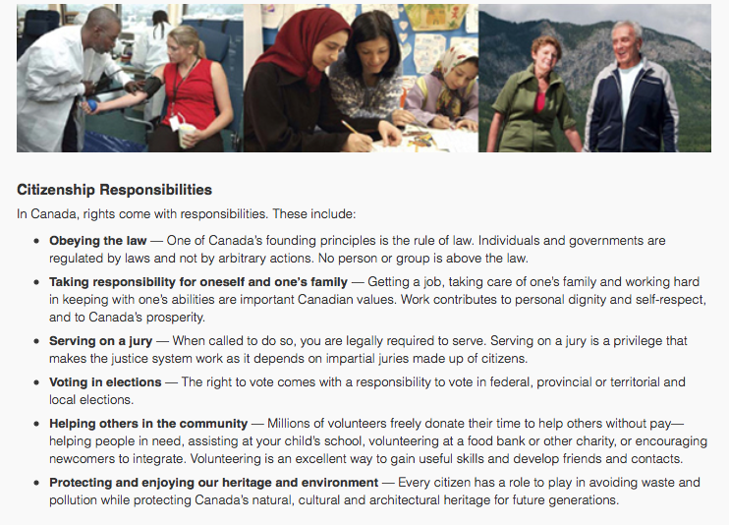

Source: http://www.cic.gc.ca/english/resources/publications/discover/section-04.asp

- As a Canadian citizen what are three things you have a responsibility to do?

- ______________________________________________________________________________
- ______________________________________________________________________________
- ______________________________________________________________________________
- What types of elections are you responsible to vote in, as a Canadian citizen?
___________________________________________________________________________
___________________________________________________________________________
- Underline, highlight or circle what your role is with respect to protecting and enjoying our environment?

Post self-assessment

I think my skills have improved as a result of completing this activity.
- Yes
- No

Learner comments:
______________________________________________________________________________
______________________________________________________________________________
______________________________________________________________________________

Assessment
Task-Based Activity: Understanding your role as a Canadian citizen
Learner Name: __________________________ Date: ____________________________

Practitioner Name: _______________________________________

Performance Descriptors | Needs Work | Improving | Excellent
A1.2: Read texts to locate and connect ideas and information
- scans text to locate information
- locates multiple pieces of information in simple texts
- makes low-level inferences
- makes connections between sentences and between paragraphs in a single text
- reads more complex texts to locate a single piece of information
- follows the main events of descriptive, narrative and informational texts
- obtains information from detailed reading
- begins to identify sources and evaluate information
The learner needs to work on the following:

This task was successfully completed ______ This task needs to be tried again ______

Practitioner Comments:

Learner Comments:

Acknowledgements:

Researched and Written by: Robyn Cook-Ritchie
Project Managed by: Lana Faessler
Advisory Committee: Diana White
Stephanie Hobbs
Helen McLeod
Carol Risidore

Pilot Sites:

Task-based activities for LWR Book 3 were piloted by 6 practitioners and 24 learners from the following LBS agencies:

Grand Erie Learning Alternatives, Brantford,
Hamilton Literacy Council
Orillia & District Literacy Council
The Literacy Group of Waterloo Region

Published by: Laubach Literacy Ontario
65 Noecker St., Room 8A
Waterloo, Ontario, N2J 2R6
Tel: (519) 743-3309 Fax: (519) 743-7520
Toll Free: 1-866 608-2574
Web: www.laubach-on.ca
© 2013

Evaluator: Sound Data Solutions, Owen Sound, Ontario

Laubach Literacy would like to thank the Ontario Trillium Foundation, which is an agency of the Government of Ontario, for funding this two-year project, entitled “Task-Based Activities for the LWR Series”.

